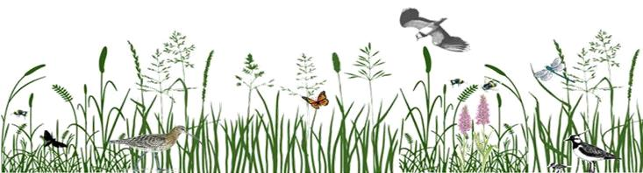
Abdon District Programme 2026
Community Wildlife Group

We look for, observe, record, and enjoy wildlife

Main Programme These are mainly outdoor field meetings, usually a walk, each of which will have a main aim, but also an opportunity to simply “see what we find”. Full details will come to you by email shortly before each event. Weather sometimes causes late change, and dates for some events will be announced nearer the time.
MARCH | Monday 2nd | Severn Rivers Trust talk & AGM
 | Tuesday 31st | Swifts, Swallows & House Martins – a wild carousel. A talk by Julie Cowley.
March to July |  | Curlew, Lapwing & Other Birds Survey
March to October |  | Bee Walk (monthly visits)
APRIL | Saturday 25th | Plant Walk – Oak Farm
April to September |  | Clee Liberty Butterfly Transect (weekly visits)
MAY | Date TBA | Dawn Chorus Walk – Brown Clee picnic area
 | Saturday 2nd | Abdon Churchyard Bioblitz & 10th Anniversary Lunch
 | Date TBA | Bird Walk – Clee Liberty (w/c 11 May)
JUNE | Date TBA | Butterfly Walk – Clee Liberty - Small Pearl-bordered Fritillary
JUNE | Sunday 7th | Plant Walk – Clee Liberty
 | Date TBA | Dormouse Nestbox Checks
JULY |  | No planned events
AUGUST | Date TBA | Dragonfly Walk
SEPTEMBER | Saturday 5th | Plant Walk
OCTOBER | Date TBA | Dormouse Nestbox Checks - Powkesmore area
 | Date TBA | Fungi Walk – Oak Farm, Ditton Priors
 | Date TBA | Bryophyte day - Oak Farm, Ditton Priors
DECEMBER/  JANUARY | Date TBA | Winter Bird Walk

“Pop-up Events For us to go looking for certain wildlife, or for us to venture “up the hill”, the weather conditions have to be right. In these cases, rather than fix dates in advance, you will receive an email giving details at short notice. Look out for emails relating to dragonflies, bilberry bumblebees, bats, moths, and upland plants (e.g. Bog Asphodel and Mountain Pansies).
Moth Mornings Miles would like to set up a moth trap at different locations, and at different seasons. Can you offer a venue? Must have an electricity supply. Fix a date with Miles, milesleach712@gmail.com which will be circulated to all members, who can arrive early morning to view and identify trap contents, and drink coffee!
Our Group owns a Bat Detector. If you would like to make use of it, contact Miles, milesleach712@gmail.com
Ongoing Recording News is always welcome of interesting wildlife observations. Please note date, species, number, location (with 6 or 10-fig map reference) and any comment. Send this to the appropriate person, who will enter it in Group records, and forward to the County Recorder where of interest.
Birds, Moths & Dragonflies: Miles, milesleach712@gmail.com Mammals: Pam, pambolathom@hotmail.com
Plants: Karl, karl94694@gmail.com Fungi: Mariel, dmdelubman@hotmail.co.uk Butterflies: Cliff, drckimber@yahoo.co.uk

