Abdon District Community Wildlife Group
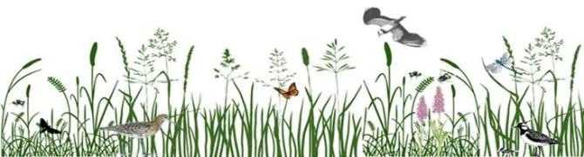
Annual Report 2025

We look for, observe, record and enjoy wildlife

Introduction
We have had a change of personnel. Cathy Beardes who has been our secretary for the last 2 years has resigned. She also very kindly recruited her replacement Tamsin Osler. Thank you, Cathy, for all that you have done over the last 2 years particularly when we were getting things together when a more formal organisational structure became necessary and for putting the Annual Report together for the last 2 years. Thank you, Tamsin, for taking on the role it is appreciated.
The Met office recently announced that 2025 was the warmest year on record for the UK in a series dating back to 1884. I came back from our summer holidays in France in mid-July to find our normally green garden brown! Local farmers were worried about having enough grass for sileage and poor yields with harvest just about to start. With the ground being so dry they didn’t know when they would be able to sew their new crops. Within a few weeks it started raining and hasn’t seemed to stop since.
There have been winners and losers due to the hot dry weather. Butterflies have had a much better year this year than last when Butterfly Conservation declared a Butterfly Emergency. This has been reflected in the results of our Butterfly Transect on Clee Liberty. However, Butterfly Conservation have highlighted that although a better year than last it has only been an average year for butterflies.
Our Curlew Survey results for the 2025 breeding season have been added to those from the other Community Wildlife Groups in the county. These are currently being analysed by Leo Smith who co-ordinates the survey. Initial results indicate that Curlews have had a bad year due to the grass not growing long enough for them to nest.
This year we tried something a little different holding a “BioBlitz” at Oak Farm in Ditton Priors. This involved groups of members surveying for different things at the same time. Some recording moths, some plants, others birds, butterflies, dragonflies etc. This was a success both in getting a baseline of the wildlife on the site and those taking part enjoying the day – particularly the pond dipping!
Thanks to all who attended an event or took part in a survey. Participating not only contributes valuable records to wildlife databases, it also offers opportunities to learn new things and enjoy time outdoors with others who share your interest. If you haven’t tried it already why not give it a go in 2026.
ML
Birds – Miles Leach
Report on the Curlew Survey results for 2024
Leo Smith came to Clee St Margaret village hall on the 19th February to give us an update on the results of the 2024 Curlew and other birds survey. Curlews are continuing to struggle with no evidence of any fledged young surviving in our area. The survey will be carried out again this year. We need more surveyors to monitor our local Curlew population. If you are interested in participating, please let me know.
Dawn Chorus Walk Oak Farm Ditton Priors 17 May
Seventeen members got up early for our dawn chorus walk. This year it took place at Oak Farm as part of our efforts to start recording the wildlife on site. We have been used to having bright and sunny mornings for this event over the last few years but, not this year, it was overcast and cold! Overall, we had a good selection of birds with 35 species recorded; see list at Appendix 1.
The highlight of the morning though was the breakfast at the Willows Café afterwards which most of us took advantage of.

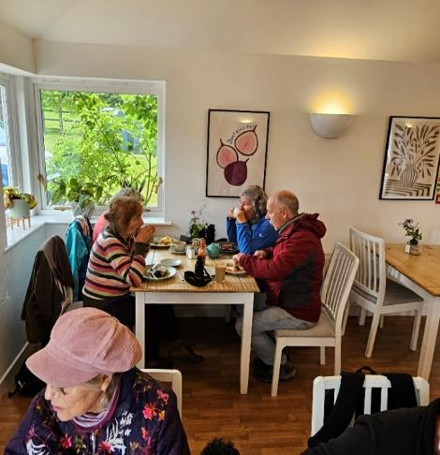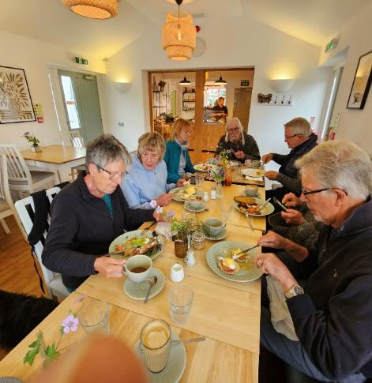

See also the bird list recorded at the Oak Farm BioBlitz.

Insects
Butterflies
In April Mike Williams of the West Midlands Branch of Butterfly Conservation very kindly came to Ditton Priors village hall and gave us a very interesting talk. Titled "Winners & Losers" Mike highlighted how our local West Midlands butterflies fared in the very bad year for butterflies in 2024. As the title suggests, some species did better than others; for example, Small Tortoiseshell had a very bad year whereas Small Copper did better. Mike highlighted that we can all help butterflies by providing as rich a habitat in our gardens for butterflies as possible.
Clee Liberty Butterfly Transect 2025 - Cliff Kimber
Not surprisingly 2025 was a bumper year for butterflies and insects in general. The record temperatures and sunshine are in stark contrast to recent cool wet summers. The 1.5 mile transect route was walked once a week by volunteers for six months. Thirteen species were recorded and a total of 644 butterflies. This compares with 15/181 in 2024, and 16/221 in 2023. A new recording this year was the Ringlet. Sightings in previous years of large skipper, brimstone, clouded yellow, purple hairstreak, holly blue were not repeated this year.
The white butterflies have been clear winners, but small tortoiseshell, comma, speckled wood, gatekeeper, meadow brown, ringlet and small heath have all seen significant increases.
The total number of butterflies seen is a 367% increase on last year. This will be hard to top in 2026 but there are reasons to be optimistic given the ongoing changes in land management of the Clee. This has been the first full year of reduced sheep grazing and alongside bracken management, tree planting and attempts to improve the wetland areas, there is every chance of increased biodiversity over coming years. Ongoing surveys such as this play an important part in providing data both locally and nationally to help monitor ecological trends.
Many thanks for the time and effort to all who took part in the transect survey in 2025. As always new volunteers, who have the time and are confident in identifying the key local species, are welcome to join us in 2026. Please contact me at drckimber@yahoo.co.uk for more information
Twenty-four of the 26 weekly walks were conducted. The table of results below has been adjusted to provide estimates of butterflies likely to have been seen in the two missing weeks.

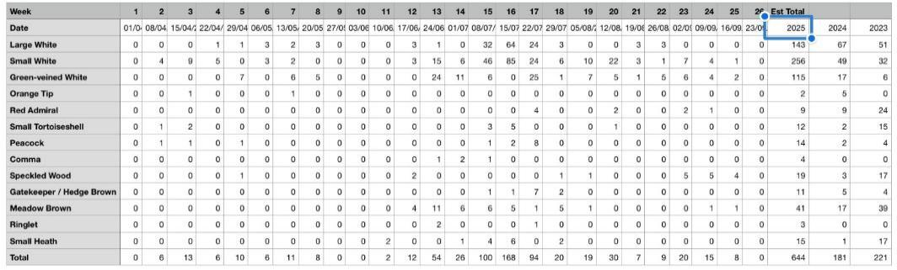
Thirteen species were recorded and a total of 644 butterflies. This compares with 15/181 in 2024, and 16/221 in 2023. A new recording this year was the Ringlet. Sightings in previous years of large skipper, brimstone, clouded yellow, purple hairstreak, holly blue were not repeated this year.
Moth Mornings – Miles Leach
Three moth mornings were held this year. Jane Gillies held one at her house in Stoke St Milborough on the 25th May, where three of us attended. On the 17th August, we revisited Martin and Sue Steer’s at Heath where 9 people attended. On the 24th August Jenny Collingridge, whose garden backs onto Oak Farm, held a moth morning as part of the Oak Farm BioBlitz day. Thank you to Jane, Martin and Sue and Jenny.
See Appendix 2 for lists of the moths recorded.
Bumblebee Surveys – Bee Walk 2025 – Cathy Beardes
This year we continued to do our Bee Walk on the same transect as last year for the months of April, May and June. Due to personal circumstances, I was unable to lead the group beyond that period. We definitely saw more bees than during the same period last year; hopefully the improvements continued through the summer, though bumblebees can find the excessive heat challenging. We did not find the elusive Bilberry Bumblebee Bombus monticola. The bees we identified are shown in Appendix 3.
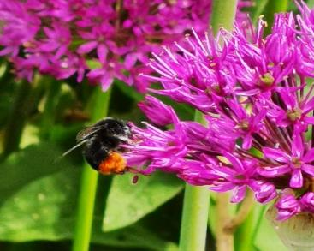
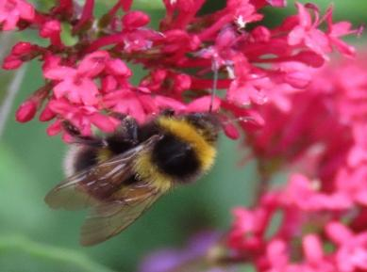
Garden bumblebee Bombus hortorum (left)
and
Red-tailed bumblebee Bombus lapidaries hard at work (right).

Mammals
Abdon District Dormouse Project Update – Lucy Grove
We had a couple of highlights from surveying our dormouse nest boxes this year and local efforts to learn more about the location and behaviour of dormice using modified trail cameras, footprint tunnels and searching for natural nests.
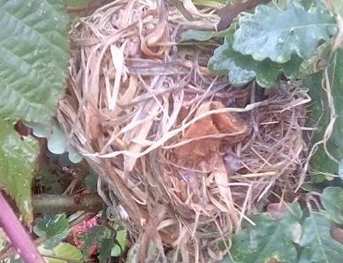
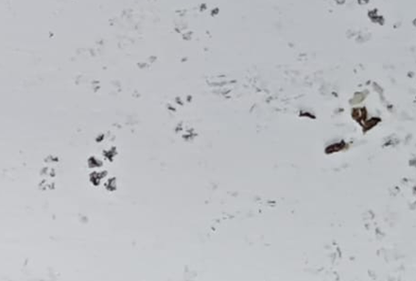

We found three dormice in torpor (a short-term survival strategy where the dormice temporarily reduce their metabolic rate, heart rate, and body temperature to conserve energy) in May on Leath Bank.
We think it was likely mum and two of last year’s young.
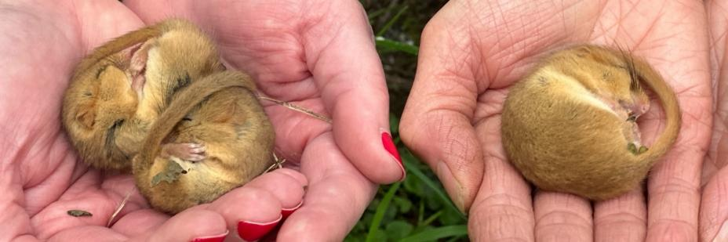

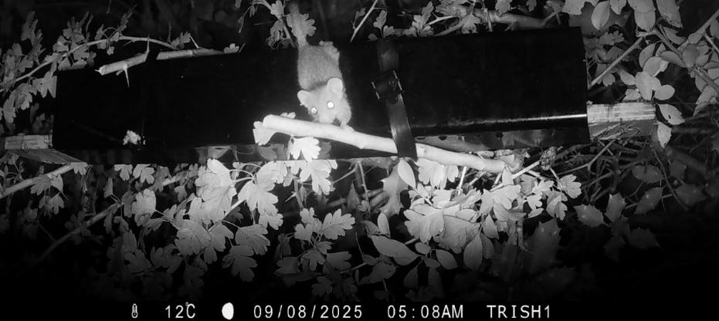

Trish Shotton took the lead on deploying and monitoring both footprint tracking tunnels and the modified trail cameras on her ground at Ditton. She captured some more wonderful footage and is building up a database of knowledge about dormouse activity patterns across different habitats. In September, Karl Leibscher found a natural nest in an oak sapling, surrounded by bramble (such an important food and movement resource for dormice!) in his woodland.
Of great excitement was our ability to lend surveying kit outside the original project area, and Mariel Lubman very quickly picked up dormice using her hedgerows near Abdon.
If you would like to borrow the group’s trail camera or footprint tunnels to search for dormice on your land (or local land you can get permission on), then please contact Lucy Grove: lucy.grove@outlook.com

Plant Life – Karl Liebscher
Churchyard Surveys

This was the concluding year for churchyard surveys, with visits to Loughton and Clee St. Margaret (see reports below). We have visited nine churchyards, found 243 different plant species, and submitted 723 records to iRecord. On average we found 80 species at each site. This is a typical number for a “meadow”.
Of course we cannot assume we found everything! It is probable that grasses were under-recorded, as our ID skills in that area could still be better.
Just 12 species were found in all nine churchyards:

Plant species found in all nine churchyards
Arum maculatum | Cuckoo Pint |  | Heracleum sphondylium | Hogweed
Bellis perennis | Daisy |  | Ilex aquifolium | Holly
Galium aparine | Cleavers |  | Sambucus nigra | Elder
Geranium robertianum | Herb Robert |  | Taraxacum agg. | Dandelion
Geum urbanum | Wood Avens |  | Taxus baccata | Yew
Hedera helix | Ivy |  | Urtica dioica | Nettle

Eleven axiophytes (plants indicative of good habitat) were found:

Axiophytes found in churchyards
Galium odoratum | Woodruff | Abdon |  | Alchemilla vulgaris agg. | Lady's-mantle | Abdon  Cleobury N.  Stoke St M.  Wheathill
Lamium galeobdolon | Yellow Archangel | Abdon |  | Ranunculus auricomus | Goldilocks Buttercup | Abdon  Wheathill
Oxalis acetosella | Wood-sorrel | Abdon  Cleobury N. |  | Geum rivale | Water Avens | Cleobury N.
Succisa pratensis | Devil's-bit Scabious | Abdon  Cleobury N. |  | Allium ursinum | Wild garlic | Stoke St M.
Hyacinthoides non-scripta | Bluebell | Abdon  Cleobury N.  Holdgate  Loughton |  | Rhinanthus minor | Yellow-rattle | Stoke St M.  Tugford
Anemone nemorosa | Wood Anemone | Abdon  Cleobury N.  Stoke St M.

Karl has all the records on spreadsheets. If you would like to be sent the results from just one or two churchyards, or from all nine, contact him on karl94694@gmail.com.
Loughton Churchyard - 5th April and 12th July
This site is home to one of the oldest living trees in Shropshire, the Loughton Yew, which was the first tree in the country to be carbon-dated. We are pleased to report it’s still there, along with 45 other species. We also found Laburnum anagyroides and Tansy Tanacetum vulgare, neither of which had we seen in the other eight churchyards surveyed. There were six common species which we had recorded in every other churchyard, but we could not find at Loughton: Yarrow, Meadow Foxtail, Sweet Vernal-grass, Field Woodrush, Ribwort Plantain and Barren Strawberry. Somehow Loughton was different.
The second visit, in July, was during one of the heatwaves, and the entire site had just been mown. We were able to add only four species to our list on this occasion!

Clee St Margaret Churchyard - 12th April
We began our visit lying on the short turf near the gateway! It took us over half an hour to record the plants we found. This was partly a reflection of our not-so-rapid ID skills, but also the fact that mown turf can still host all sorts.
We found Knotted Cranesbill Geranium nodosum, known at only a couple of sites in Shropshire. It was under the boundary hedge, no doubt an escapee from the adjacent garden. We also found Honeysuckle Lonicera periclymenum, surprisingly the only occasion when we have recorded this species in visits to nine churchyards.
In all, 58 species were recorded. Unfortunately, circumstances meant that a mid-summer visit did not happen. Hopefully we’ll put that right in 2026.

Monad SO6183 Walk - 5th April
Since 2000 there has been a shift in botanical recording towards using the 1km square, or “monad”. Collating the records from these squares and putting them on a map, shows the distribution of each species. By repeating the process every ten years, we can see how plant populations are changing. In Shropshire there are 3,740 1km squares. Despite the best efforts of botanists, about 450 monads in Shropshire have next to no records. These have been nicknamed “Shanklins”, after Dr Jon Shanklin of Cambridge, who has started a drive to have these squares surveyed. There are a few Shanklins in “our patch”, and the aim of this walk was to give monad SO6183 some records to be proud of!
Five of us started from Loughton Chapel (which actually stands in the adjacent monad SO6182), followed the lane to the crossroads, turned right, followed that lane, and then walked a short distance along a public footpath. We recorded 57 species (see Appendix 4), and these records have all now been submitted through iRecord.

Ashfield Coppice - 17th May
Spring is the time to see woodland plant life, and on this occasion, we were fortunate to have the company of professional botanist, John Handley. Over the years, Karl had recorded about 150 plant species on this 5-acre site. Could we possibly find more? The first new record was right by the gate – Scaly Male Fern Dryopteris affinis. Another wonderful new find was Sanicle Sanicula europaea, an ancient woodland indicator. John’s professional eye easily spotted some new grass species - seven in all! - including Wood Melick Melica uniflora, an ancient woodland indicator and Spreading Meadow-grass Poa humilis. The total number of grass species recorded in this “woodland” is now 24! A most curious find was Great Forget-me-not Brunnera macrophylla. This is a garden escape, an alien species, found at only eight sites in Shropshire, mainly in Shrewsbury. We found it under the roadside hedge by a passing place. It’s known that garden fly-tipping has happened here, and that suggests how this oddity arrived.

Mountain Pansy Walk – 1st June
On 6th June 2021 we found 25 Mountain Pansy Viola lutea plants at the top of Clee Liberty. This was quite special, as this species had not previously been recorded at this site. We returned on 9th June 2024 and could find none. On June 1st 2025, a good number of us set out from Heatham Gate with high hopes.
The Mountain Pansy distribution map is taken from the Shropshire Flora. From this, you can see how significant our little colony might be. The last record on Abdon Burf was 1983.

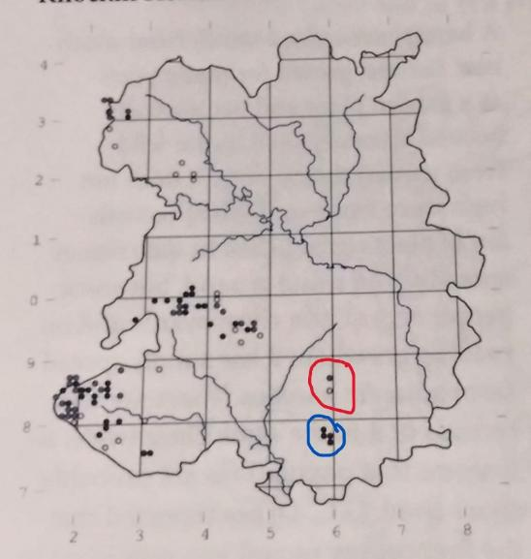

Brown Clee circled in red, Titterstone Clee in blue.

From The Flora & Vegetation of Shropshire
Lockton & Whild, 2015

On the walk up we found an earthstar, Geastrum fimbriatum. It typically grows in rich humus under deciduous trees. Presumably the wind had carried it from its origin. It is not common.
Shortly before the top, our attention was drawn to a moss-like plant which had numerous orange-hairy globes atop long, thin stems. We were able to carefully remove the orange-hairy part, revealing a fruiting capsule, the shape of which told us that we were looking at Common Haircap Polytrichum commune. (Polytrichum translates as “many hairs”)
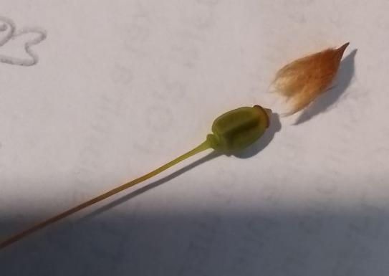

The haircap removed from the fruit capsule
of Polytrichum commune.

Photo by Karl Liebscher

As we approached the summit, the cloud came down and the rain began just as we started looking for Mountain Pansies. Alas, we found none. Were we simply too late? Had the prolonged warm and sunny weather meant that they had flowered early? They are tolerant of heavy grazing, so we don’t think we can blame the sheep.
We ate our lunch in the shelter of the beech trees, and then braved the weather for a rapid descent.

Oak Farm, Ditton Priors – 24th August
Our wild plant survey focused on four habitats: grassland, woodland, hedgerow and pond. We recorded a total of 76 species, which is not very impressive. Factors which probably caused this were:
- It was late in the season. A visit in May/June would probably find more
- The drought conditions had probably led to some species “packing up shop” early.
- The wood is basically an oak plantation on former improved grassland, and has yet to develop a rich woodland flora.
- We gave little attention to the main parts of the field. Not only were they recently mown “improved grassland”, but the drought conditions also made identification difficult.
- The stream might well have had additional species, but we were only able to access it at a few points.

However, we were delighted to make two special finds:
In the woodland, we found several plants of Sanicle Sanicula europaea in a cluster. Sanicle is an Ancient Woodland Indicator, although we knew we were not in such a wood. The seeds are covered in tiny hooked bristles, to enable dispersion by furry animals. This find is probably the result of seed being brought in by a mammal. An early coloniser of the young woodland!
Near the pond, Mariel found several spikes of Broad-leaved Helleborine Epipactis helleborine. This species is decreasing in Shropshire, so it is good to know this site is now in the hands of a conservation-minded body.
We can look forward to further visits to Oak farm and building on that species list.
Oak Farm Bryophytes and Lichens – 26th October
The arrival of rain in the Autumn was well-timed for this visit, bringing desiccated bryophytes back to life. On this three-hour visit, we focused on the wood and the stream. Jane had recently embraced the world of lichens, which enabled us to start looking at a new group. We recorded two dozen species, not a lot, but identifying these two groups is a little more challenging. There are, no doubt, many more species on the site and we look forward to adding to our list in the future.

Two Special Finds
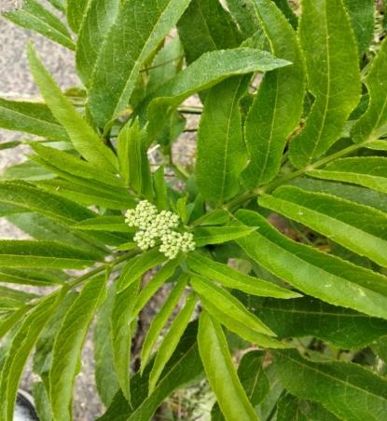
Dwarf Elder
Cycling along the lane from Bouldon to Peaton in June, Karl spotted some large, unusual plants growing in the verge. Close inspection revealed it as Dwarf Elder Sambucus ebulus. This verge at Peaton is one of just six sites in Shropshire where it is to be found. It is a perennial that comes up each year, and some stems at Peaton were almost six feet high. I returned the next day to take photographs, only to discover the verge had been mown, and only remnants remained!
Photograph by Karl Liebscher

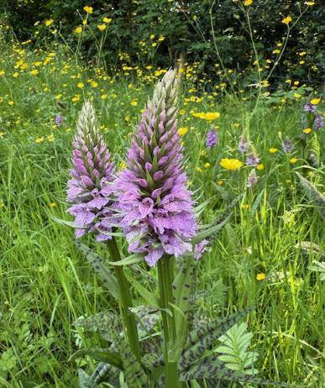

Tall Marsh Orchid
On a visit to a local traditional hay meadow, we were shown some exceptionally large orchids. Following close examination and further research, it was concluded they were Tall Marsh Orchids Dactylorhiza x grandis (Dactylorhiza fuchsii x praetermissa). These have been recorded at only a handful of locations in Shropshire. The County Recorder has labelled this record as “sensitive”, and so the site is not named here!

Ona visit to a local traditional hay meadow, we were shown some exceptionally large orchids. Following close examination and further research, it was concluded they were Tall Marsh Orchids Dactylorhiza x grandis (Dactylorhiza fuchsii x praetermissa). These have been recorded at only a handful of locations in Shropshire. The County Recorder has labelled this record as “sensitive”, and so the site is not named here!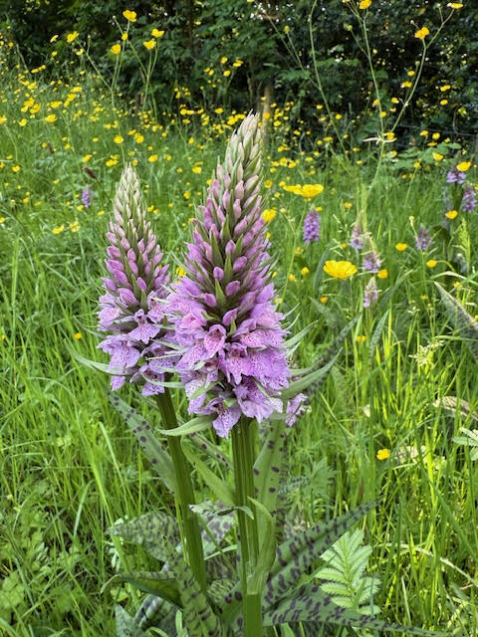

New Year Plant Hunt – 4th January 2026
Since 2012 intrepid botanists across Britain have gone in search of flowers in bloom at New Year, a citizen science survey involving several thousand volunteers, coordinated by the Botanical Society of Britain & Ireland (BSBI). The data collected is helping botanists understand the effects of global warming on flowering periods, and the implications for pollinators for example.
This year Abdon joined the hunt! January 4th brought proper winter conditions with a feel-like temperature of -5°, and a covering of snow. Five of us managed to get to Clee St Margaret and spend three hours looking for flowers. After just 10 minutes in the Village Hall grounds, we found several daisies in bloom. Little did we know, that after two hours we would be up to just two species. The second species, Greater Periwinkle, caused a debate, as much of the plant was in a garden. But some had jumped the boundary into the hedge-bank, and could be considered “naturalised”. It went onto our list! Walking across a sunny corner of Clee Liberty yielded nothing, but as we came into the village, a solitary Lesser Celandine was spotted on a ditch side. Further along the same ditch, Primrose and Stinking Hellebore were found in flower. Things were looking up. Approaching the churchyard, we found Green Hellebore, and then snowdrops in the graveyard. Walking back up the lane, a few flowering spikes of Dogs Mercury were spotted.
We had found eight species in flower in three hours of hunting!
Submitting our records that evening, both species of Helleborus triggered a red-lettered response. H. viridis isn’t usually recorded in flower as part of the plant hunt and H. foetidus only rarely recorded. Were we about to be shown two red cards? That would make our total less than the average per hunt in Scotland! Well, if we will go looking for flowers at over 200m on a freezing, snowy day, what can we expect? Anyhow, it was great fun, and we will be back next year.
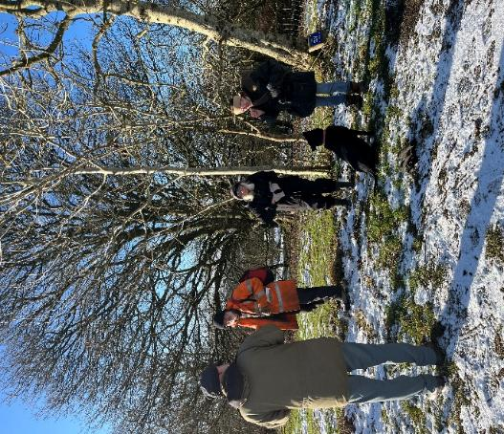

New Year Plant Hunters at Heatham Gate

Photo by Carol Wood

Footnote: The “New Year Plant Hunt” took place over four days. Almost 2000 walks were organised right across the British Isles. On average each recorded about 13 plants in bloom. Across the country a total of 658 species were found in bloom. Walks near the south coast recorded 70 to 100 species in flower. Daisy, our first record, was found in flower on over 60% of the walks.
Clee Liberty Common
Butterfly and Bird Survey – Cliff Kimber
On the twentieth of June, Chris Moore and I surveyed parts of Clee Liberty looking particularly for Small Pearl Bordered Fritillary (SPBF) butterflies and Marsh Violets which the caterpillars feed on. There were sightings on the Clee several years ago but none within the last year, also on the Burwarton Estate and near Cockshutford. The SPBF has suffered a steady decline in numbers since the 1970s and is now on the Red List as a high priority conservation species. Part of its decline is related to the reduction of damp grassland/ moorland habitats, something the Clee St Margaret Parish Council and Clee Liberty Commoners’ Association have been trying to improve over the past couple of years.

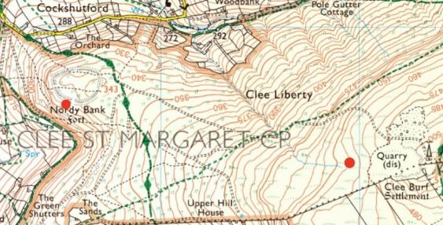
Over a five-hour period we focussed our attention around Nordy Bank, then continued up to the wetland area just below the quarry. In total there were three separate SPBF sightings: one on Nordy Bank and two below the quarry. We found no evidence of Marsh violets.
Obviously, this is a limited survey due to number of surveyors and the large area involved but the sightings are encouraging.
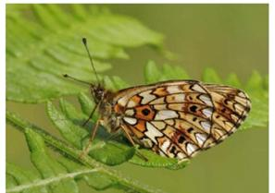
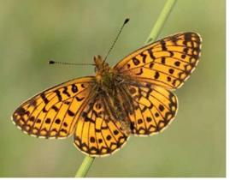
Small Pearl-Bordered Fritillary Photos by Iain Leach

We also recorded all other butterfly sightings on the day; Small Tortoiseshell, Small Heath (3), Green-veined White, Meadow Brown and Small White (4).
In addition, we carried out a general bird survey with the following results: Swallow (3), Kite, Raven, Stonechat, Yellowhammer, Linnet (3), Skylark (2), Meadow Pipit (2), Sparrowhawk, Carrion Crow (2). We particularly looked for Wheatears but with no success. They have been seen intermittently on Clee Liberty over the past few years but a more extensive survey by ADCWG three years ago found no evidence of nesting birds. Any sightings are likely to be of birds on their migratory routes but we live in hope.
Both of the above surveys are a limited snapshot of the species inhabiting Clee Liberty. There will be more on different days and times of the year, and with more volunteers. With active habitat management schemes underway on the common, we are considering a more extensive program of surveys to monitor their impact over the coming years. Watch this space.

Other Events
BioBlitz at Oak Farm Ditton Priors

Oak Farm is managed by the Ditton Priors Land Trust. David Munn, a member of the management committee, is keen to improve the biodiversity of the site and to make it more accessible to the local community. He is setting up a “community environmental centre” in one of the buildings behind the Willows Café. At the 2024 AGM it was suggested that we could carry out a BioBlitz at some point. I thought that this was the opportunity to do so to identify a baseline of the wildlife on the site.

We held this event on Sunday 24 August. We were lucky with the weather it being a lovely sunny day. We had at least 20 members in different groups carrying out various surveys recording moths from 2 traps set up the previous evening, plants, bees, birds, butterflies, dragonflies and other insects etc.

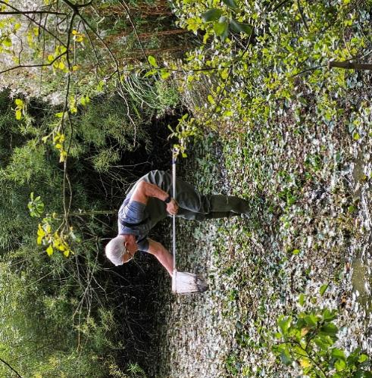
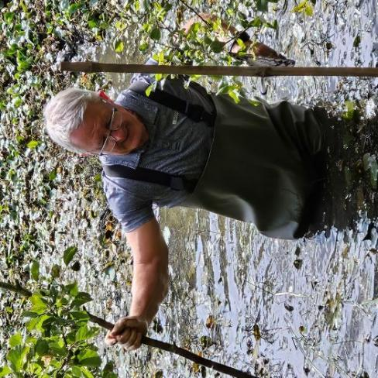

A highlight of the day was a pond dipping session supervised by Lucy Groves with Lucy and Chris Moore doing a great job identifying the findings. Special mention must go to Dave Munn for him wading into the pool to pond dip, for his bravery, his netting skills and the entertainment value!

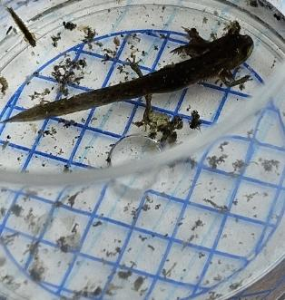
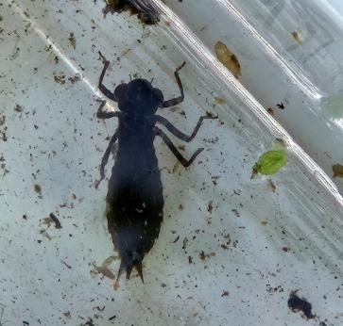

Dragonfly Larva Young Newt

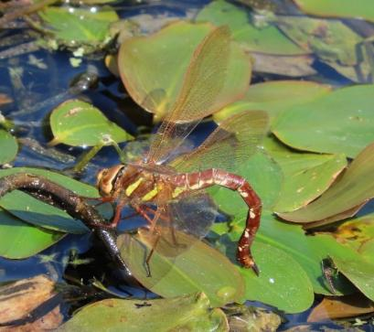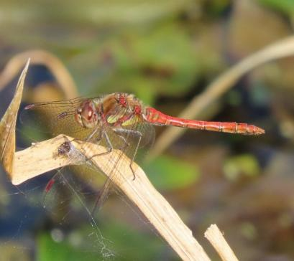

Female Brown Hawker ovipositing Male Common Darter

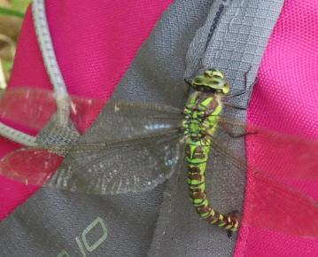
A confused female Southern Hawker ovipositing on a rucksack. It had landed on a number of us in its search for places to deposit eggs.

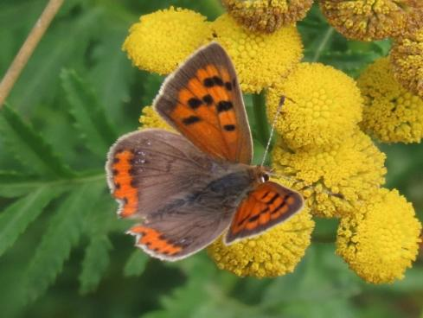
A Small Copper Form caeruleopunctata showing additional blue markings on the hindwing. In Small Copper aberrations are often found in the autumn generation after a hot summer.
(ref Butterflies of the West Midlands).
Thank you to all those who took part in a very interesting and enjoyable day and to those who dropped in to add their support. Special thanks to Sarah Munn for supplying tea, coffee and an amazing selection of cakes to keep us going through the day! Thanks to Karl, Cathy, Cliff for the species lists.

See Appendix 5 for lists of what we recorded.
APPENDICES

Appendix 1: Dawn Chorus Bird List Oak Farm 17 May 2025

House Sparrow Starling
Blackbird Garden Warbler
Woodpigeon Coal tit
Jackdaw Swifts (over industrial Estate)
Chiffchaff Linnet
Carion Crow Mistle Thrush
Blackcap Meadow Pipit
Blue Tit
Greenfinch
Wren
Robin
Lesser Black-backed Gull
Stock Dove
Chaffinch
Song Thrush
Goldcrest
Great Tit
Willow Warbler
Jay
Magpie
Marsh Tit
Redstart
Treecreeper
Goldfinch
Dunnock
Pheasant
Pied Wagtail
Appendix 2: Moths Recorded
Stoke St Milborough
Macro moths
Brimstone Moth | 4 | Common
Pale Tussock | 11 | Common
Scorched Wing | 3 | Local |  | Number of species |  | 32
Common Marbled Carpet | 7 | Common
White Ermine | 5 | Common |  | Number of individuals |  | 108
Clouded Silver | 3 | Common
Flame Shoulder | 12 | Common
Barred Umber | 1 | Local
Spectacle | 3 | Common
Dingy Footman | 2 | Common
Lobster Moth | 1 | Common
Buff Ermine | 12 | Common
Scalloped Hazel | 6 | Common
Buff-Tip | 2 | Common
Green Carpet | 2 | Common
Beautiful Golden Y | 1 | Common
Poplar Hawk-moth | 2 | Common
Clouded-bordered Brindle | 2 | Common
Flame | 1 | Common
Silver-ground Carpet | 6 | Common
Pebble Hook-tip | 1 | Common
Straw Dot | 2 | Common
Small Square-spot | 4 | Common
Ingrailed Clay | 2 | Common
Heart & Dart | 1 | Common
Shoulder Stripe | 1 | Common
Marbled Minor | 2 | Common
Broken-barred Carpet | 1 | Common
Mottled Pug | 2 | Common
May Highflyer | 3 | Common
Dwarf Pug | 1 | Common
Setaceous Hebrew Character | 1 | Common
Common Pug | 1 | Common
Micro moths
Small Magpie | 1 | Common
Tinea trinotella | 1 | Common |  | Number of species |  | 4
Celypha lacunana | 1 | Common
Epinotia immundana | 1 | Common |  | Number of individuals |  | 4
Heath

Macro moths
Brimstone Moth | 1 | Common
Broad-bordered Yellow Underwing | 3 | Common
Lesser Broad-bordered Yellow Underwing | 8 | Common |  | Number of species |  | 22
Common Wainscot | 5 | Common
Poplar Hawk-moth | 2 | Common |  | Number of individuals |  | 115
Setaceous Hebrew Character | 42 | Common
Flame Shoulder | 12 | Common
Rosy Rustic | 1 | Common
Shuttle-shaped Dart | 2 | Common
Centre-barred Sallow | 4 | Common
Large Yellow Underwing | 10 | Common
Flame Carpet | 1 | Common
Square-spot Rustic | 8 | Common
Straw Dot | 2 | Common
Copper Underwing | 3 | Common
Canary-shouldered Thorn | 2 | Common
Flounced Rustic | 1 | Common
Common Marbled Carpet | 2 | Common
Blood-vein | 2 | Common
Dark Arches | 1 | Common
Pebble Prominent | 1 | Common
Yellow Shell | 1 | Common
Small Square-spot | 1 | Common
Oak Farm

Macro moths
Brimstone Moth | 15 | Common
Chinese Character | 2 | Common
Lesser Swallow Prominent | 2 | Common |  | Number of species |  | 52
Brindled Green | 4 | Common
Dusky Thorn | 4 | Common |  | Number of individuals |  | 352
Canary-shouldered Thorn | 2 | Common
September Thorn | 1 | Common |  | NB two moth traps used.
Common Marbled Carpet | 2 | Common
Centre-barred Sallow | 15 | Common
Snout | 1 | Common
Setaceous Hebrew Character | 54 | Common
Common Wainscot | 51 | Common
Double-striped Pug | 2 | Common
Light Emerald | 2 | Common
Square-spot Rustic | 34 | Common
Flame Shoulder | 13 | Common
Lesser Broad-bordered Yellow Underwing | 4 | Common
Coronet | 1 | Local
Copper Underwing | 2 | Common
Flame | 1 | Common
Flounced Rustic | 2 | Common
Feathered Gothic | 1 | Common
Large Yellow Underwing | 10 | Common
Six-striped Rustic | 4 | Common
Common Rustic | 2 | Common
Small Square-spot | 2 | Common
Dark Arches | 1 | Common
Orange Swift | 1 | Common
Heart & Dart | 2 | Common
Spectacle | 1 | Common
Pale Mottled Willow | 1 | M/C
Lesser Yellow Underwing | 1 | Common
Rosy Rustic | 1 | Common
Chinese Character | 5 | Common
Brimstone Moth | 2 | Common
Dusky Thorn | 2 | Common
Setaceous Hebrew Character | 42 | Common
Square-spot Rustic | 11 | Common
Common Marbled Carpet | 4 | Common
Lesser Broad-bordered Yellow Underwing | 4 | Common
Flounced Rustic | 2 | Common
Snout | 1 | Common
Flame Shoulder | 5 | Common
Ruby Tiger | 1 | Common
Large Yellow Underwing | 7 | Common
Maple Pug | 1 | Local
Common Wainscot | 13 | Common
Copper Underwing | 1 | Common
Brindled Green | 1 | Common
Centre-barred Sallow | 6 | Common
Light Emerald | 1 | Common
Green Carpet | 1 | Common
Magpie | 1 | Common
Micro moths
Epiphyas postvittana | 3 | Common
Pandemis corylana | 2 | Common
Celypha lacunana | 2 | Common |  | Number of species |  | 7
Anania coronata | 1 | Common
Argyresthia goedartella | 2 | Common |  | Number of individuals |  | 13
Cataclysta lemnata | 2 | Common
Celypha striana | 1 | Common

Appendix 3 – Bumblebees recorded on Bee Walks
Bumblebee species | Castes and numbers seen
Common Carder bee (Bombus pascuorum) | Queen -3, worker-21
Red-tailed Bumblebee (B. lapidaries) | Queen -4, worker-50, male-1
Early Bumblebee (B. pratorum) | Worker -2
White-tailed Bumblebee (B. lucorum)  Buff-tailed Bumblebee (B. terrestris) | Queen -1  Queen -1
 | White/Buff-tail workers - 36
Tree Bumblebee (B. hypnorum) | Queen -1, worker-1
Garden Bumblebee( B. hortorum) | Queen -1, worker-31
Heath Bumblebee (B. jonellus) | none recorded
Bilberry Bumblebee (B monticola) | none recorded
Field Cuckoo Bumblebee (B. campestris) | Female -1
Unidentified bumblebees | 8 (flew by)

Appendix 4 – Plants recorded

Monad SO6183 5th April 2025 (Karl, Dee, Sue C., Carol, Trish)
Acer pseudopltanus | Sycamore |  | Lonicera periclymenum | Honeysuckle
Aedopodium podograria | Ground Elder |  | Mercurialis perennis | Dogs Mervury
Alliaria petiolata | Hedge Garlic |  | Picea abies | Norway Spruce
Alnus glutinosa | Alder |  | Polypodium vulgare | Polypody
Anthriscus sylvaticus | Cow Parsley |  | Potentilla reptans | Cinquefoil
Arctium sp. | Burdock |  | Prunus spinosa | Blackthorn
Arum maculatum | Wild Arum |  | Quercus robur | Oak
Cardamine flexuosa | Wavy Bitter Cress |  | Ranunculus repens | Creeping Buttercup
Chrysoplenium oppositifolium | Opposite-leaved Golden Saxifrage |  | Ribes uva-crispa | Gooseberry
Cirsium vulgare | Spear thistle |  | Rosa arvensis | Field Rose
Corylus avellana | Hazel |  | Rosa canina | Dog Rose
Crataegus monogyna | Hawthorn |  | Rubus fruticosus agg | Bramble
Digitalis purpurea | Foxglove |  | Rubus idaeus | Raspberry
Epilobium montanum | Broad-leaved Willowherb |  | Rumex obtusifolius | Broad-leaved Dock
Ficaria verna | Lesser Celandine |  | Sambucus nigra | Elder
Filipendula ulmaria | Meadowsweet |  | Senecio vulgaris | Groundsel
Fragaria vesca | Wild Strawberry |  | Silene dioica | Red Campion
Gallium aparine | Cleavers |  | Stachys sylvatica | Hedge Woundwort
Geranium robertianum | Herb Robert |  | Stellaria holostea | Greater Stitchwort
Geum urbanum | Wood Avens |  | Symphytum sp. | Comfrey
Glechoma hederacea | Ground Ivy |  | Tamus communis | Black Bryony
Hedera helix | Ivy |  | Taraxacum agg | Dandelion
Heracleum sphondylium | Hogweed |  | Taxus baccata | Yew
Ilex aquifolium | Holly |  | Trifolium repens | White Clover
Lamiastrum galeobdolon | Yellow Archangel |  | Ulmus sp. | Elm
Lamium album | White Dead Nettle |  | Urtica dioica | Nettle
Lamium purpureum | Red Dead Nettle |  | Veronica montana | Wood Speedwell
Lapsana communis | Nipplewort |  | Viburnum opulus | Guelder Rose
 |  |  | Vicia sepium | Vetch

Survey of Bryophytes & Lichens at Oak Farm 26.10.2025 by Abdon Wildlife Group
 | (Mariel, Jane, Deborah, Mark, Cathy and Karl)
 |  |  | Wood | Stream bank
Liverworts | Radula complanata | Even Scalewort
 | Pellia endiviifolia | Endive Pellia
Mosses | Atricum undulatum. | Common Smoothcap
 | Brachythecium rutabulum | Rough-stalked Feather-moss
 | Fissidens taxifolius | Common Pocket-moss
 | Hypnum andoi | Mammilate Plait-moss
 | Kindbergia praelonga | Common Feather-moss
 | Mnium stellare | Starry Thyme-moss
 | Orthotrichum affine | Wood Bristle-moss
 | Rhynchostegium confertum | Clustered Feather-moss
 | Ulota crispa/bruchii | Crisped/Bruch’s Pincushion
Lichens | Candelariella sp. | Egg Yolk Lichens
 | Cladonia sp.
 | Evernia | Oak ‘Moss’ Lichen
 | Hypotrachyna revoluta/afrorevoluta
 | Lecanora chlarotera
 | Lecanora sp. | Rim lichens
 | Parmelia sulcata | Hammered/Cracked Lichen Shield Lichen
 | Parmotrema perlatum | Powered Ruffle Lichen
 | Possibly Flavoparmelia sp.
 | Ramalina farinacea
 | Xanthoria calcicola
 | Xanthoria parietina
 | Xanthoria polycarpa
Comment
We spent three hours on site, and surveyed just a small part of the wood, and a short stretch of the stream.
There are, no doubt, many more species present.

Appendix 5 - Species seen at the Oak Farm BioBlitz – 24/08/2025

Bees
Buff tail bumblebee
Common Carder bee
Red-tailed bumblebee
Southern cuckoo bee

Butterflies
Large White
Small White
Green-veined White
Holly Blue
Red Admiral
Comma
Small tortoiseshell

Dragonflies
Common Darter
Brown Hawker (f)
Southern Hawker (f)

Other Insects & Spiders
Seven-spot ladybird
Garden spider
Seven-spot ladybird
Harvestman spider
Grasshopper
Bluebottle
Grass veneer
Spotted Orb Web spider
Crane Flies

Pond dipping species identified
Greater water boatman
Dragonfly larva
Mayfly larva
Damselfly larva
Ramshorn snail
Freshwater shrimps
Midge Larva
Daphnia
Pond snail
Baby newt
Lesser water boatman
Water louse
Great diving beetle
Ceratopogonids
Froglet
Toadlet
Dytiscid beetle
Phantom Midge

Mammals
Vole

Birds
Woodpigeon Robin
Red Kite Goldfinch
Buzzard
Magpie
Blue Tit
House Martin
Treecreeper

Final Word
Another busy year for the group. A particular highlight for me was the Bioblitz that we held at Oak Farm in Ditton Priors. It brought together a good number of our members, we recorded a lot and it was a great social occasion in fine weather. We will be visiting the site again in 2026 to do some more surveys. We will have to try to get some more pond dipping in to the programme!
We only cancelled two events this year, both due to bad weather, the Dragonfly Walk and the Fungi Walk. We did however have some dragonfly action at Oak Farm during the Bioblitz. Dave Munn braved the weather and turned up for the Fungi Walk at Oak Farm and photographed a number of fungi.
Thank you to all who organised and led events and to those who attended them. I look forward to seeing you at an event in 2026.
Miles Leach

